Cairo University Faculty of Computers and Artificial Intelligence



**Advanced SE**

**Software design specification document**

**2022**

**Project Team**

|  |  |  |
| --- | --- | --- |
| **ID** | **Name** | **Email** |
| **20200307** | **عبدااله محمود زكريا** |  |
| **20200302** | **عبدالله صالح سيد** |  |
| **20200274** | **عبدالتواب محمد عبدالتواب** |  |
| **20200406** | **ماريو مدحت اديب** |  |

Contents

Instructions[To be removed] 2

Class diagram design 2

Class diagram Explanation 3

Sequence diagram design 3

Github repository link 4

# Instructions[To be removed]

* **IMPORTANT. Rename this document to** CS352_LabGroupNumber_Phase1_StudentID1_StudentID2_StudentID3_StudentID4**_SDS Document.docx**
* **Remove the following notes and any red notes**

# 

# Class diagram design

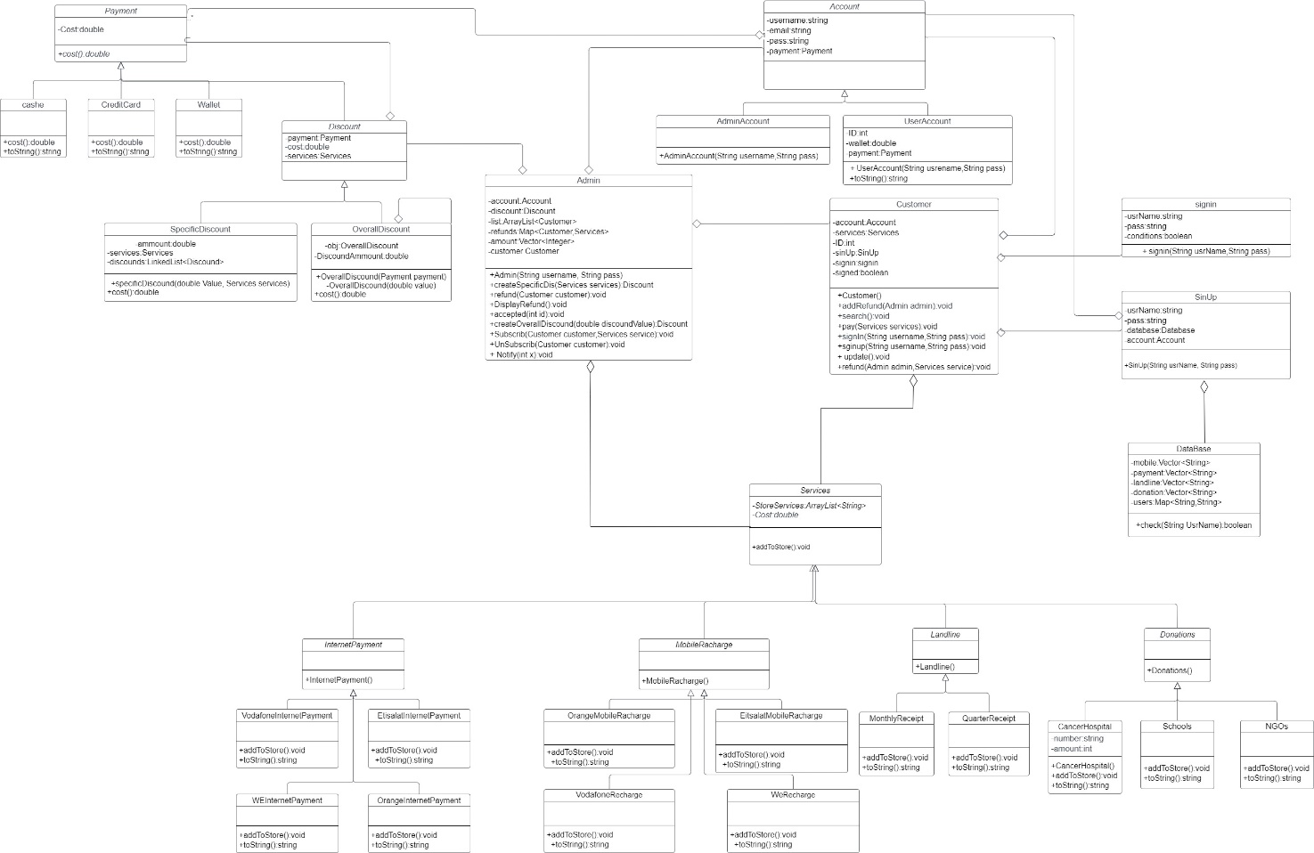

# Class diagram Explanation

* **We use decorator pattern in discount because we have different type of discount,**

# 

# Sequence diagram design

1. **Specific discount**

# 

# Payment

# Diagram, schematic Description automatically generatedsign UP

# Custmor refund

# Sign in

# Search

# Admin

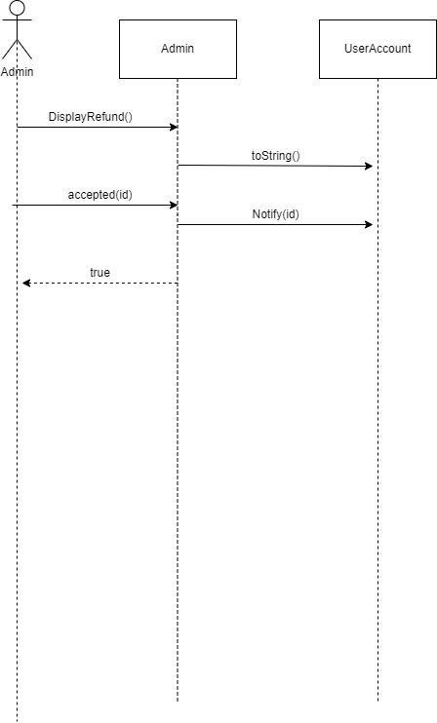

# GitHub repository link

* **https://github.com/Abdallah531/Advanced-Software-Project.git**